First Make repository on Android Studio

https://www.bing.com/videos/search?q=how+to+connect+android+project+to+git&qpvt=how+to+connect+android+project+to+git&FORM=VDRE#view=detail&mid=AEBD680AEA9883F10986AEBD680AEA9883F10986

1 step

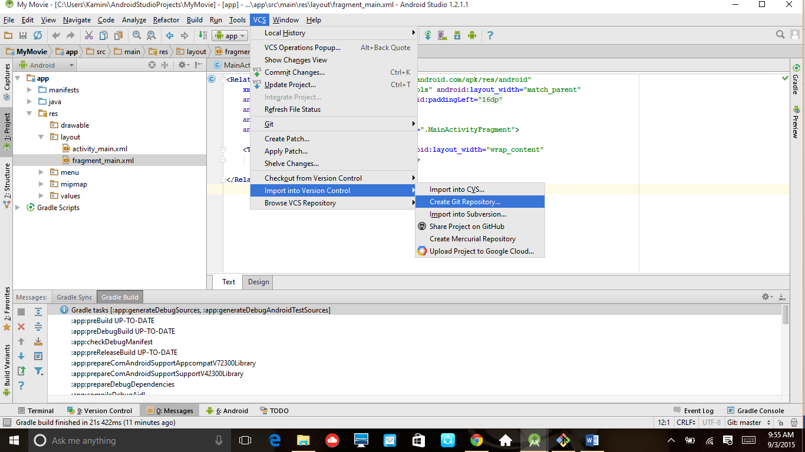

2 step : create repository in your project like MyMovie then clieck on ok Button

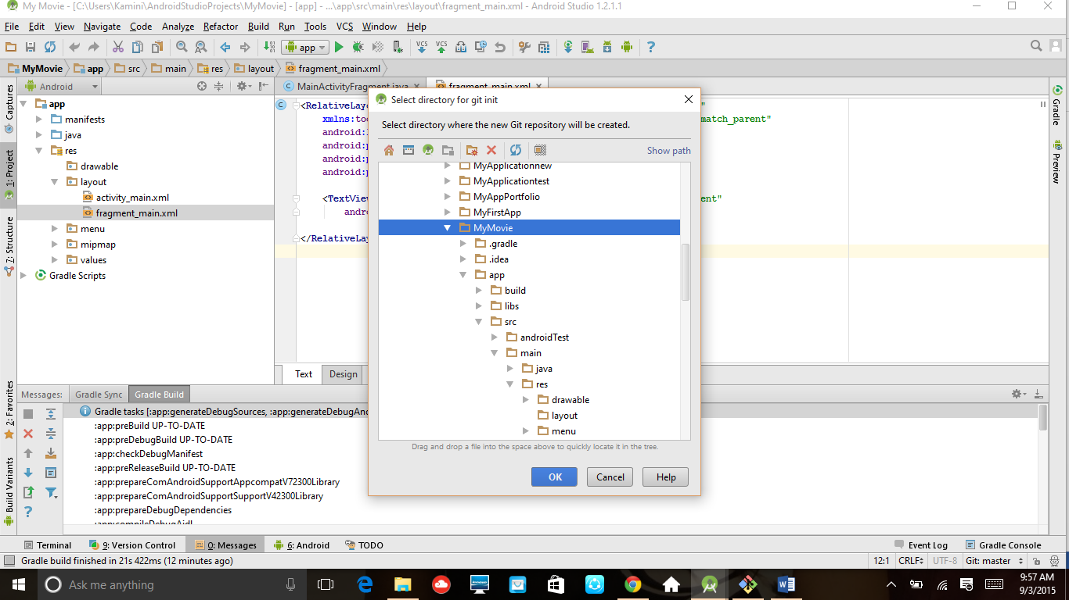

3 Step

Open git bash check with ls –a command

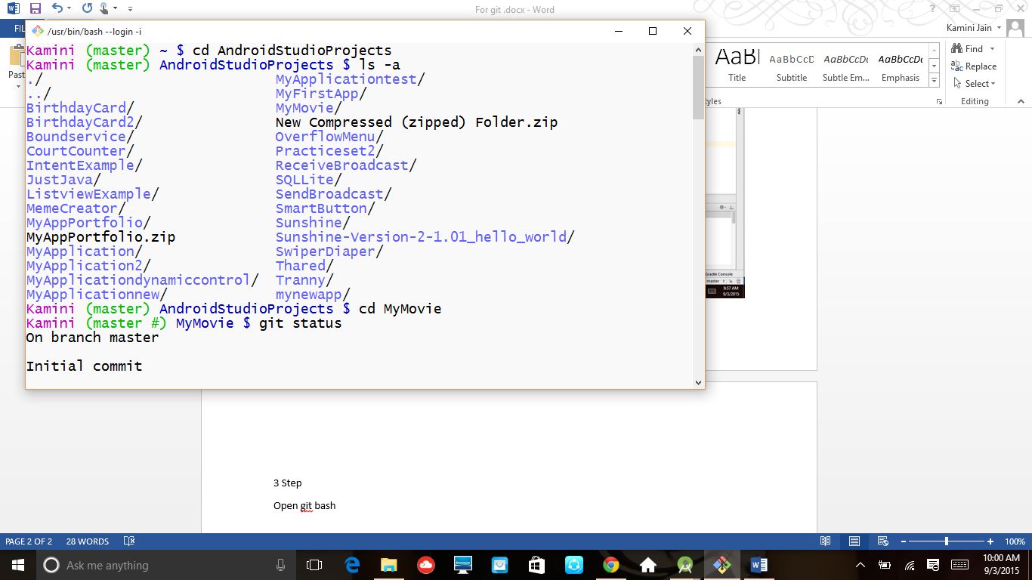

4 step go on ur directory us cd directory name like cd mymovie then give command git status

This command give the status of files which is not included

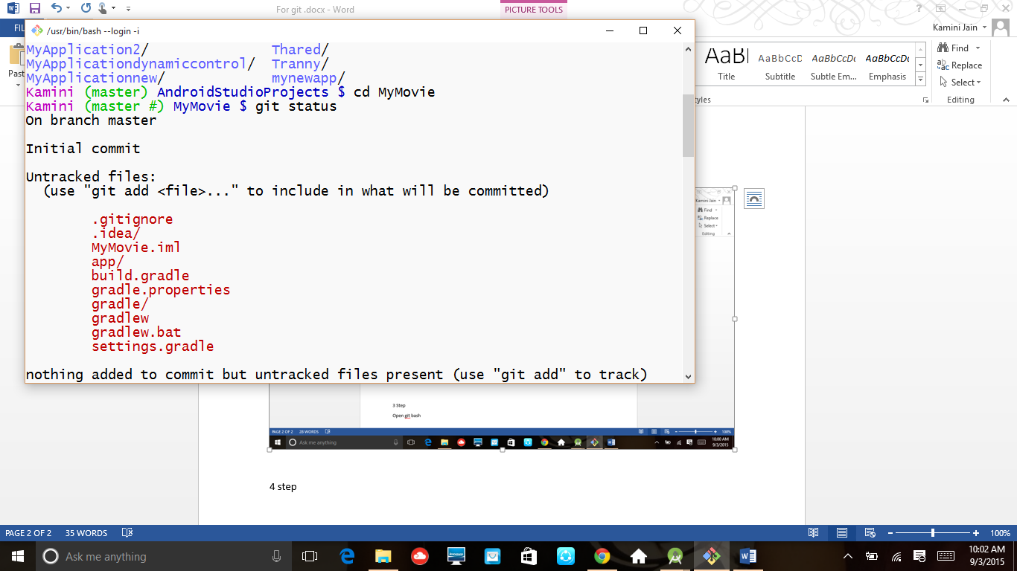

5 step type git add . for add all files in repositary

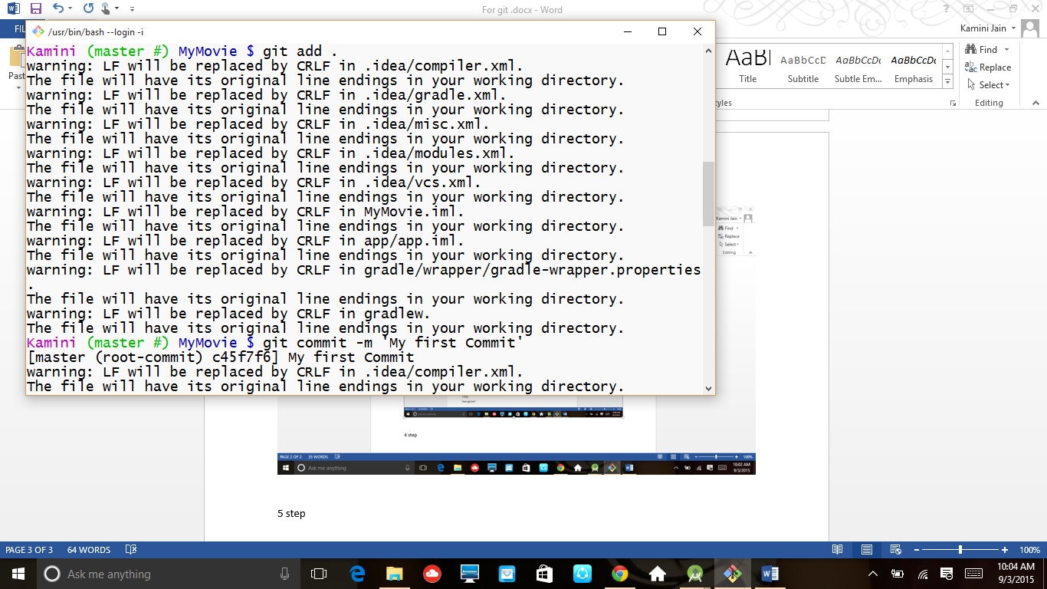

6 step git commit –m ‘any message’ for commit any files

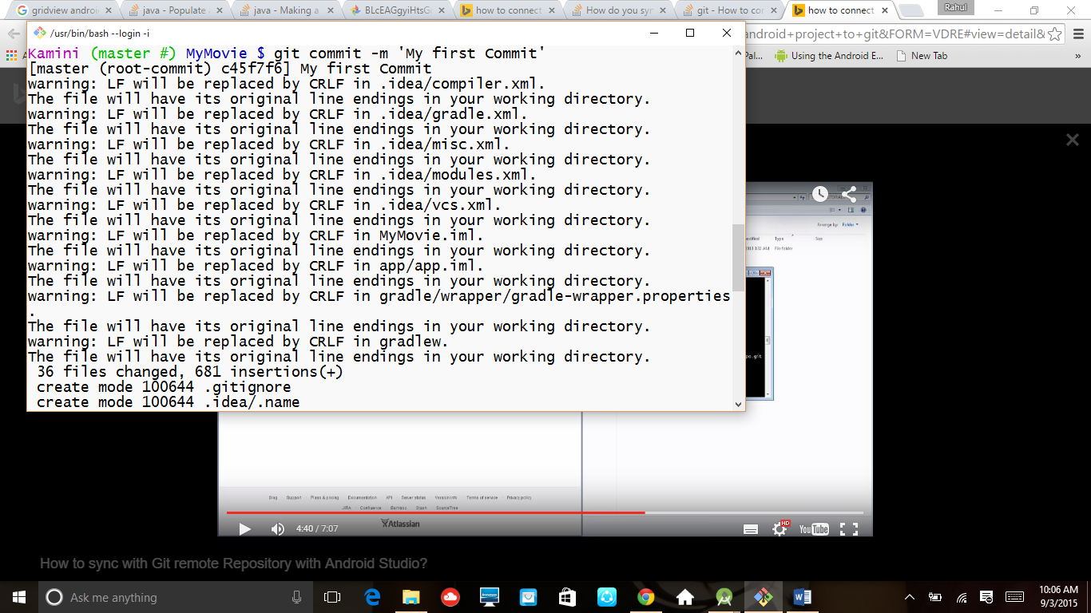

7 step git status to check the status of files

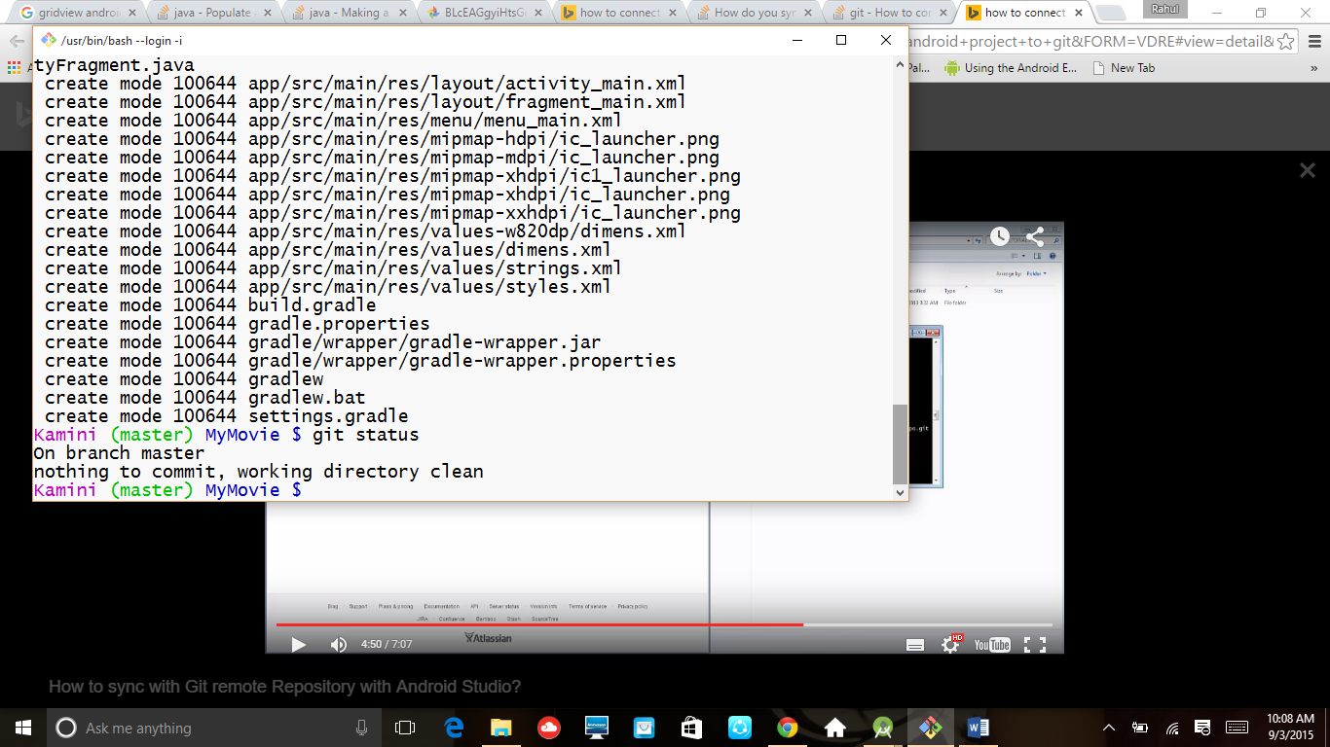

8) step imake one repository on github and then use git remote add origin https://github.com/jainkamini/MyMovieProject.git

To add my branch in github repository

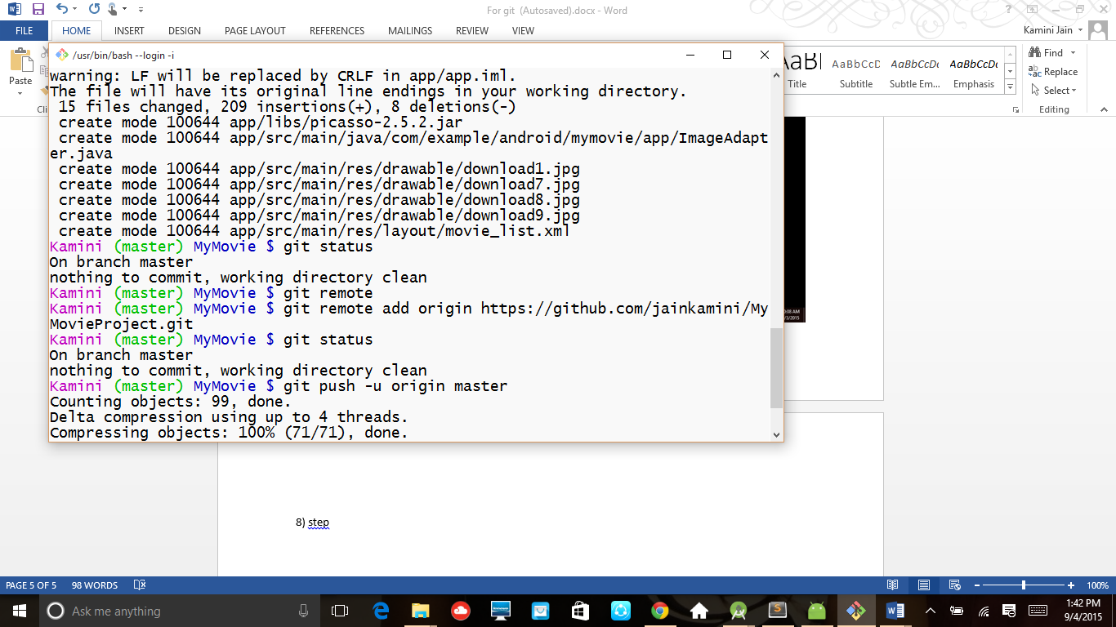

9) step afterthat use push command to send commit files in github repository

Git push –u origin master